

CSE302: Database Systems (Section 1)
[SUMMER 2023]

Project Report

Building a Database Application for
ICC Men's Cricket World Cup 2023

ICC WORLD CUP 2023 (mini project) (oracle.com)

Submitted by:

Student ID | Student Name | Contribution Percentage
2021-3-60-117 | Sagor Ahmed | 45
2021-3-60-185 | Syeda Tasmiah Chowdhury Orpa | 55

1. E-R Model of the Project:
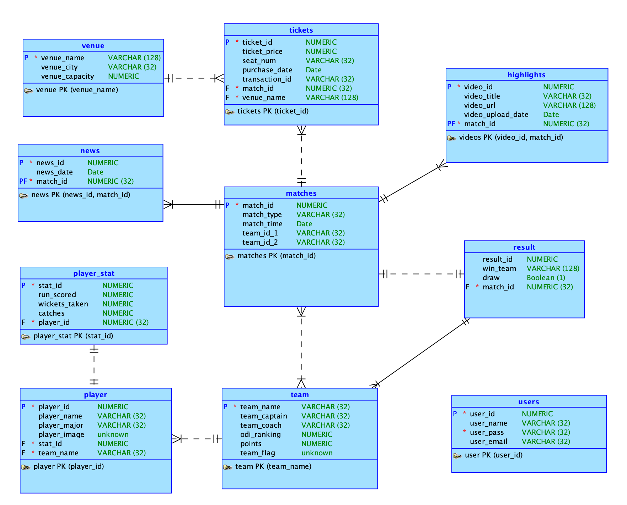
1. Relational Data Model of the Project:
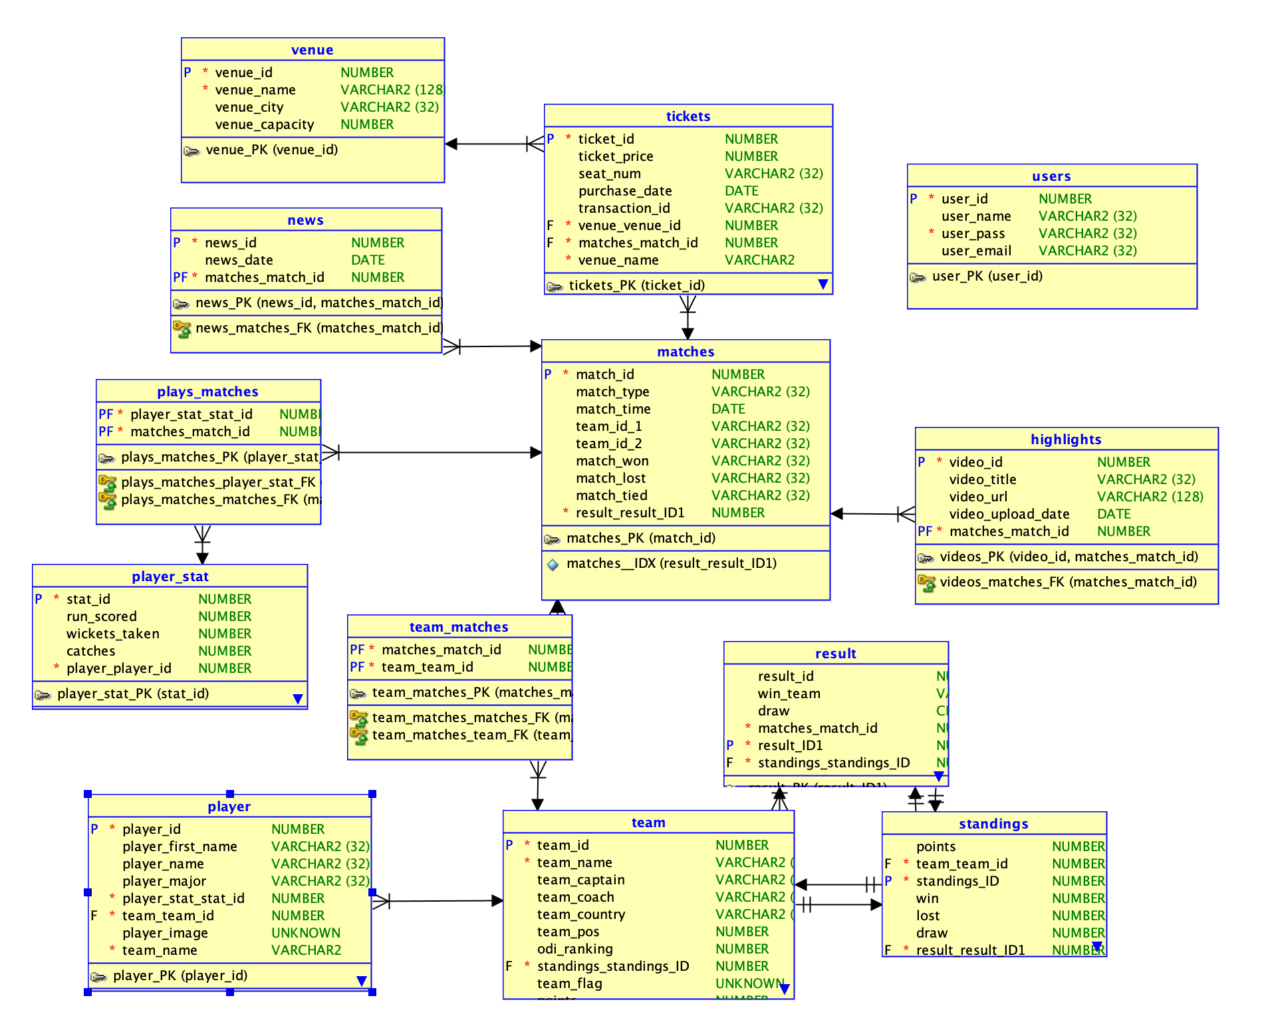
2. Implementation Checklist

Description | Remarks
Project ID | 267902
Workspace Name | cse302_project_icc2023
Workspace Email | sagorahmedmunna@gmail.com
Workspace Password | cse302project
Authentication Type | Application Express/Custom (keep the relevant one)
Username1 | DMRH
Password1 | DMRH
Username2 | ADMIN
Password2 | ADMIN
Username3 | sagorahmedmunna@gmail.com
Password3 | cse302project
Uploaded and Displayed Images in Reports | Yes
Implemented Page-wise Authorization | Yes
Number of Reports with Forms | 9
Number of Master-detail Forms | 1
Number of Reports based on Queries, Aggregate Queries | 4
Number of Parameterized Reports | 1
Number of Graphs/Charts | 1
Included any trigger/other feature which is not taught in class. If yes, please explain briefly. | Yes, we have used triggers on the standings for the match. Also we have implemented a customized logo in the login page with custom authorization.
Write the most unique feature/functionality in your application or the page of your application that you are proud of. Explain briefly. | Dashboard.

3. Reports with Forms

Report Page Number and Name | Form Page Number and Name | Table
11 - Teams | 2 - team input | team
13 - venues | 3 - venue input | venue
16 - matches | 4 - match input | match
41 - match finished | 6 - result input | resut
22 - players info | 7 - player input | player
 | 8 - player stat input | player stat
 | 38 - Registration | user_logins
48 - tickets | 45 - ticket input | tickets
52 - news | 46 - news input | news
50 - highlights | 47 - highlights input | highlights

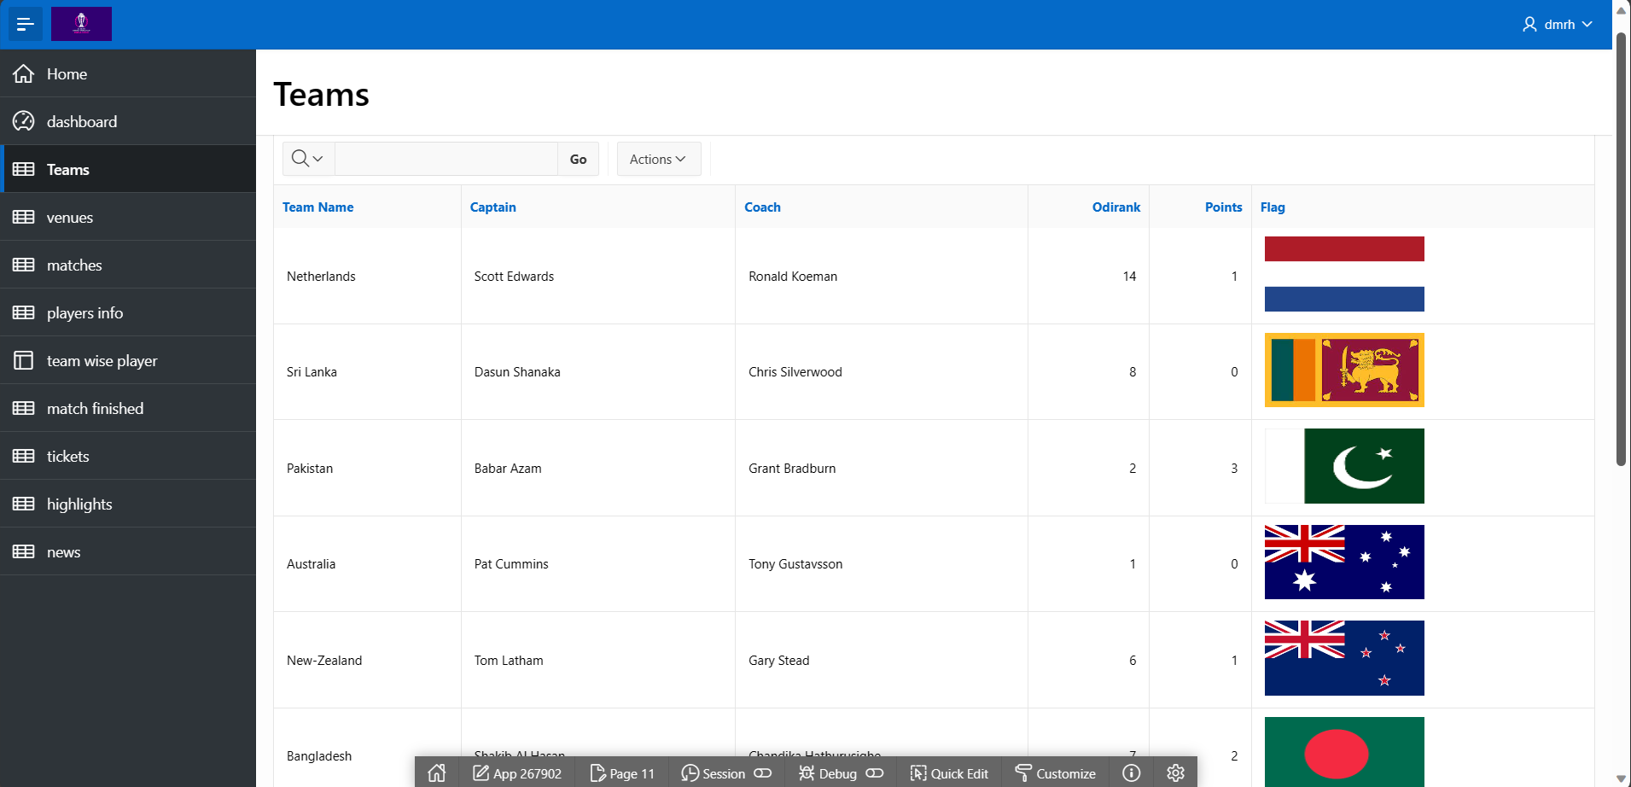
3.1 Report of Teams
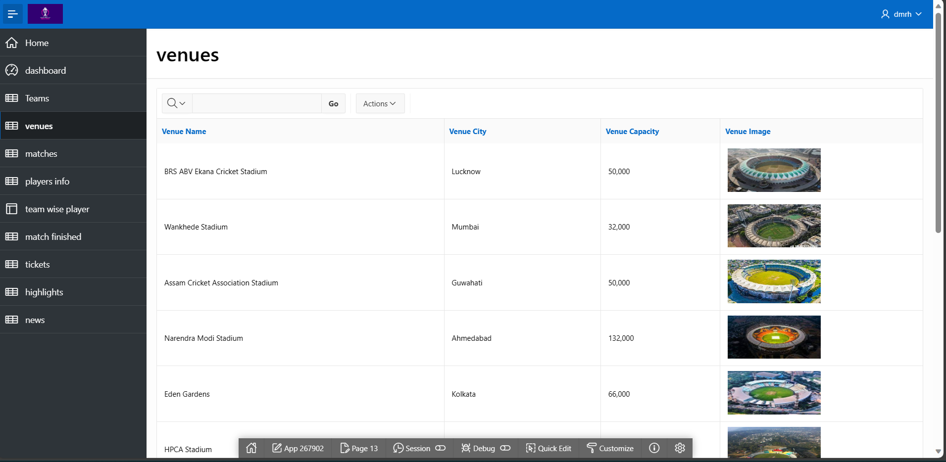
3.2 Report of venues

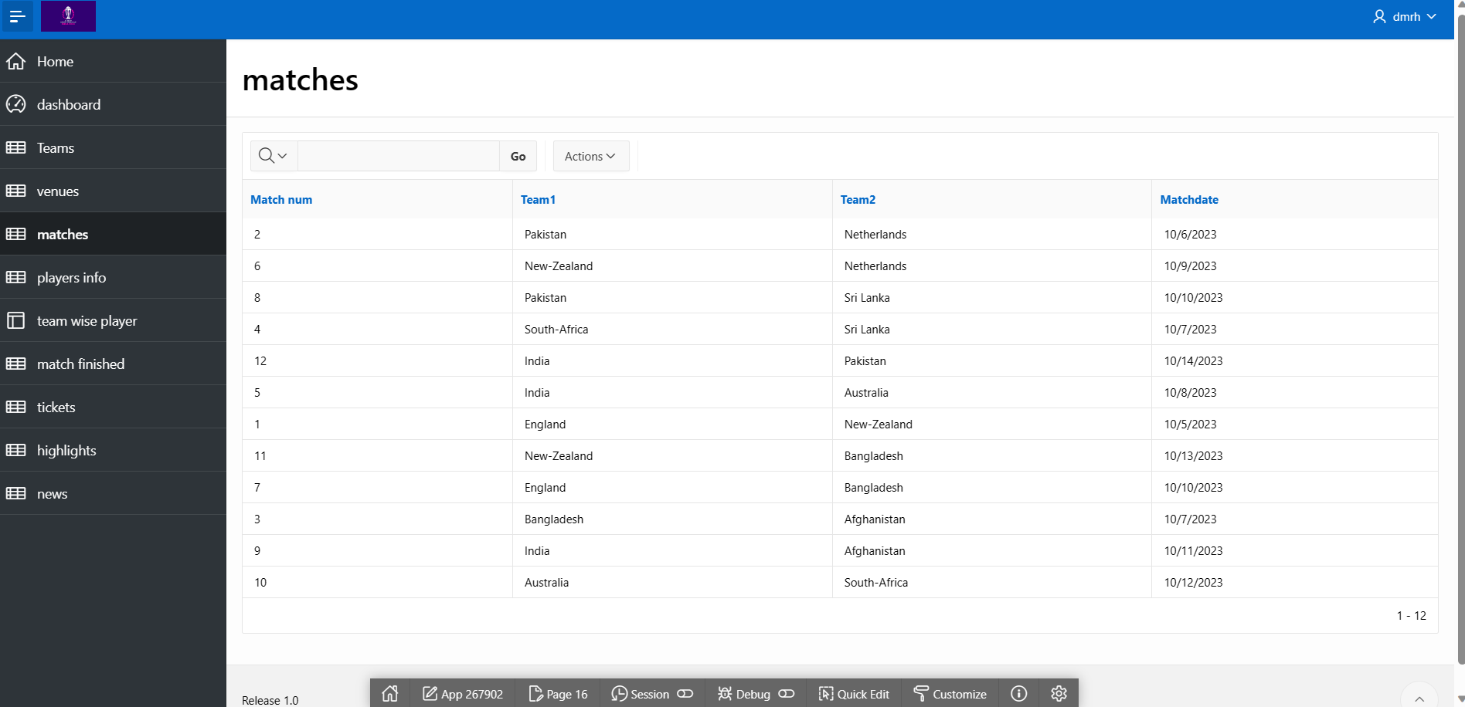
3.3 Report of matches

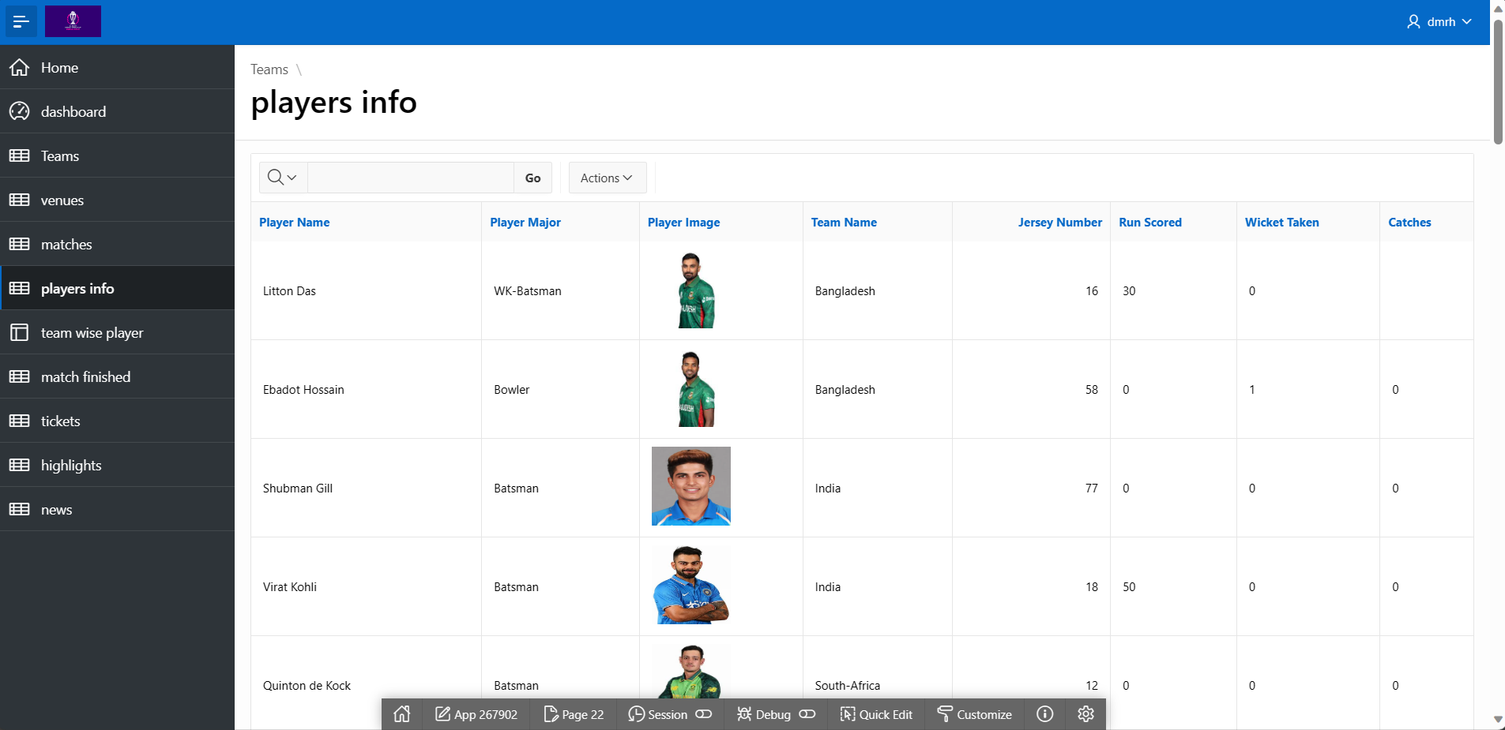
3.4 Report of players info

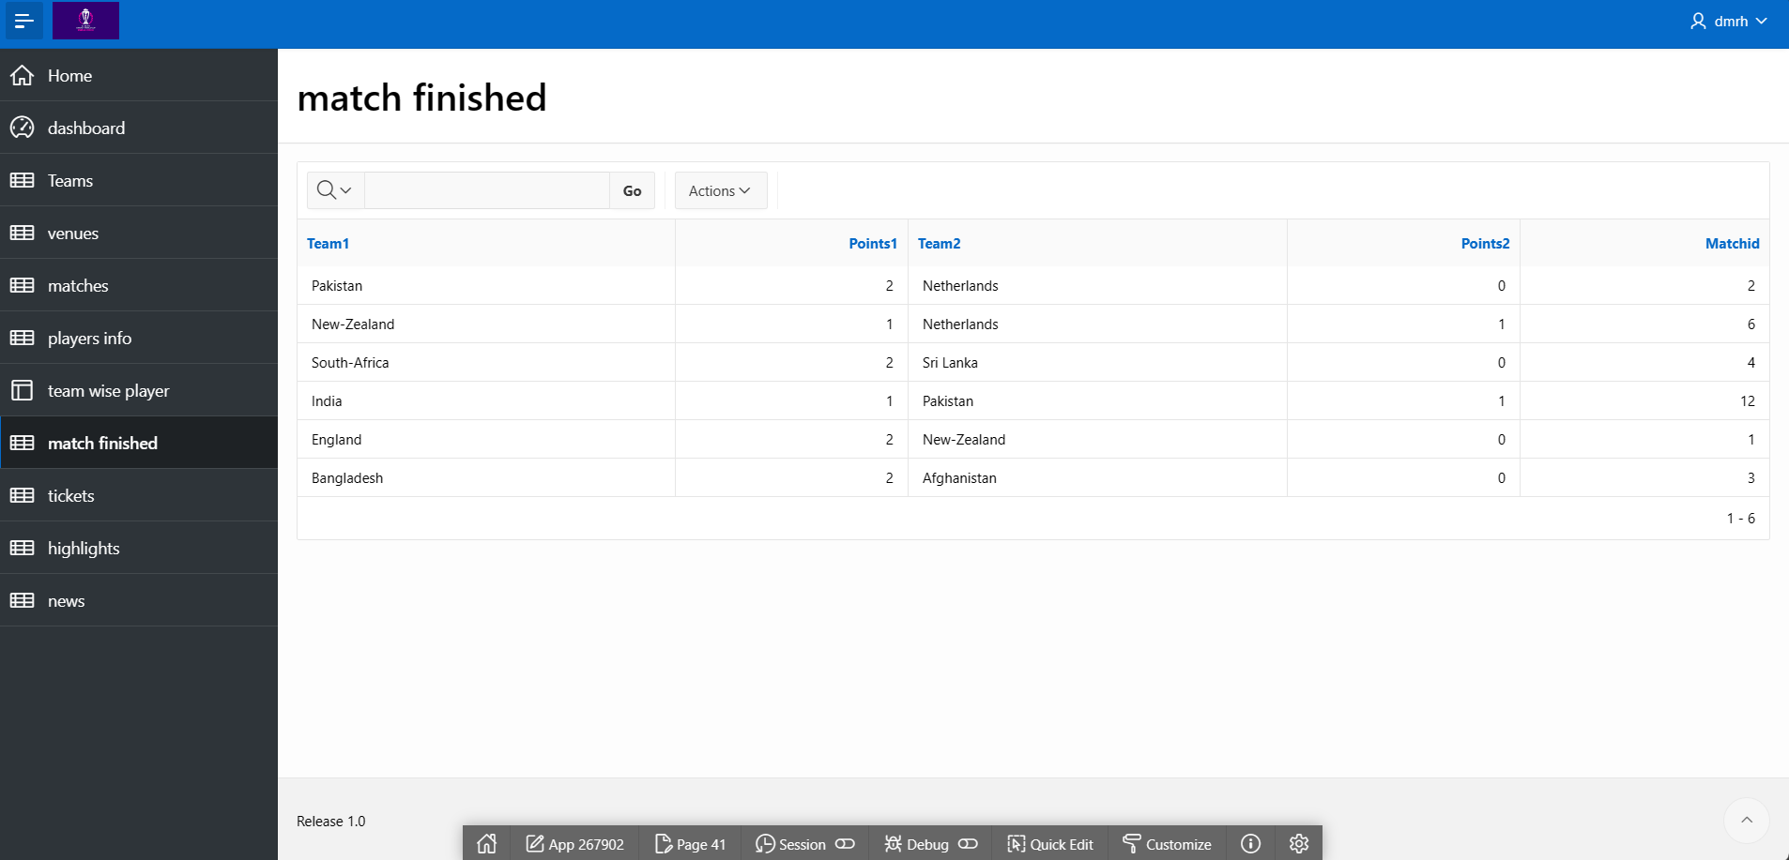
3.5 Report of match finished
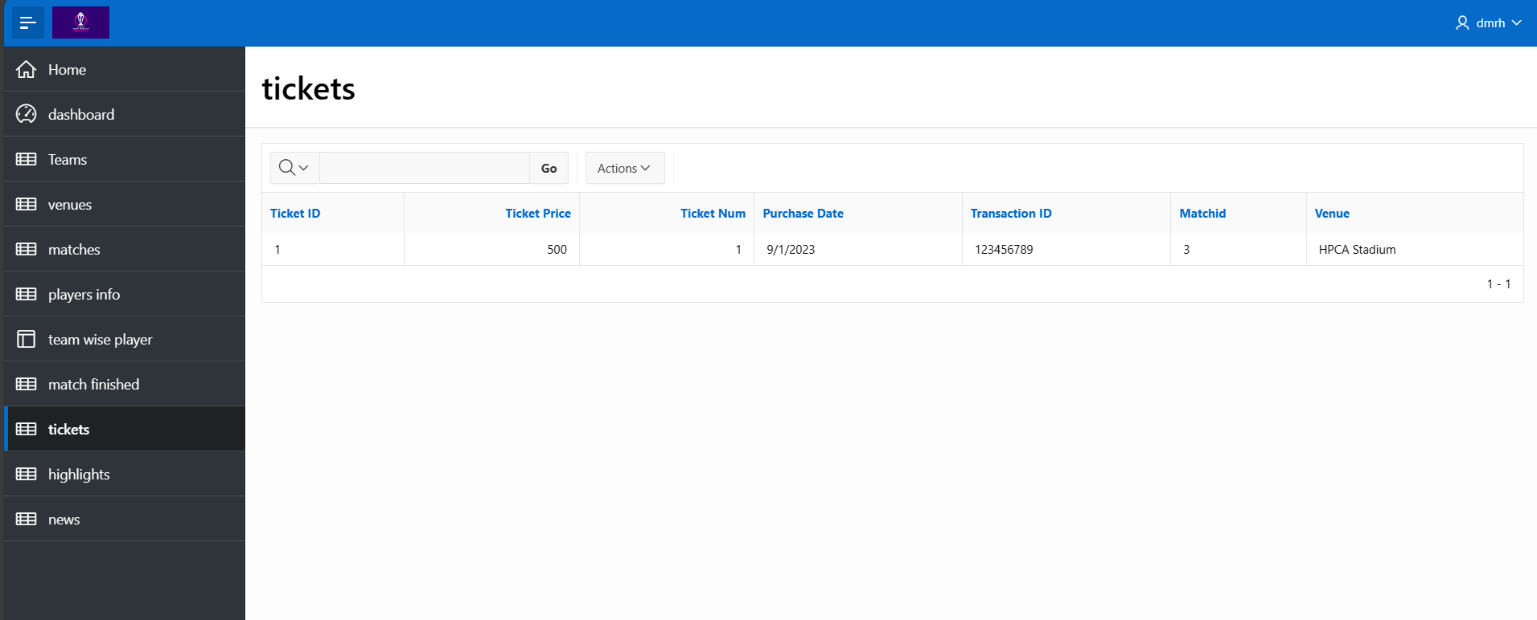
3.6 Report of tickets

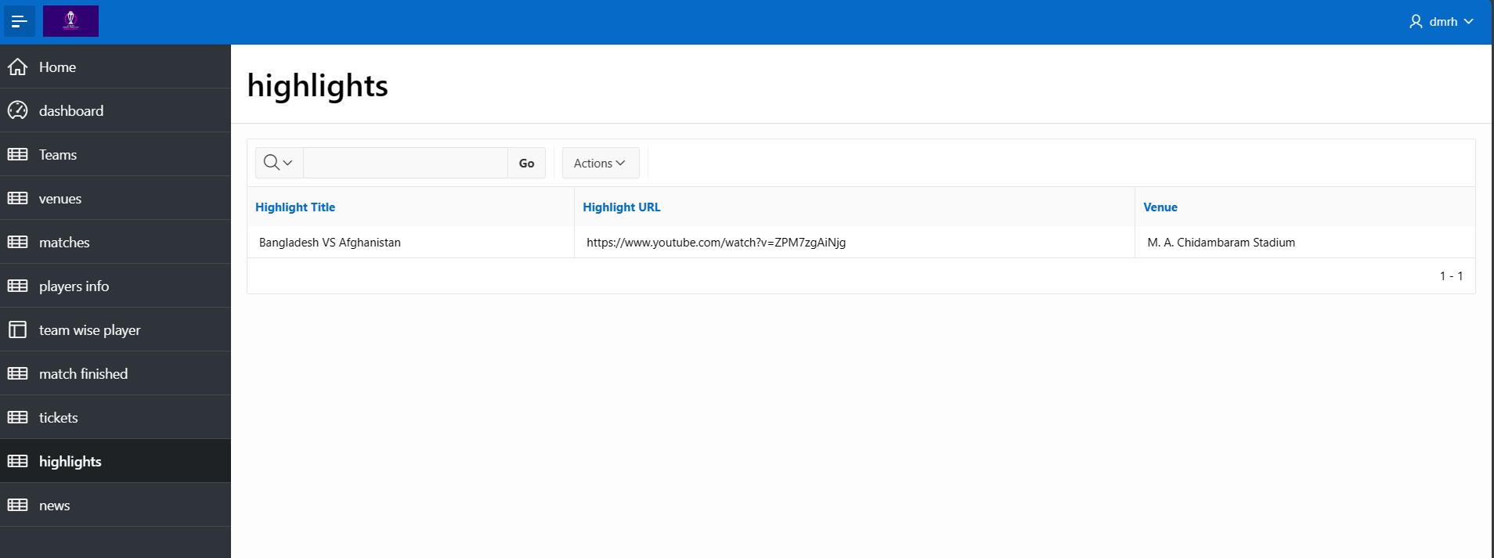
3.7 Report of highlights

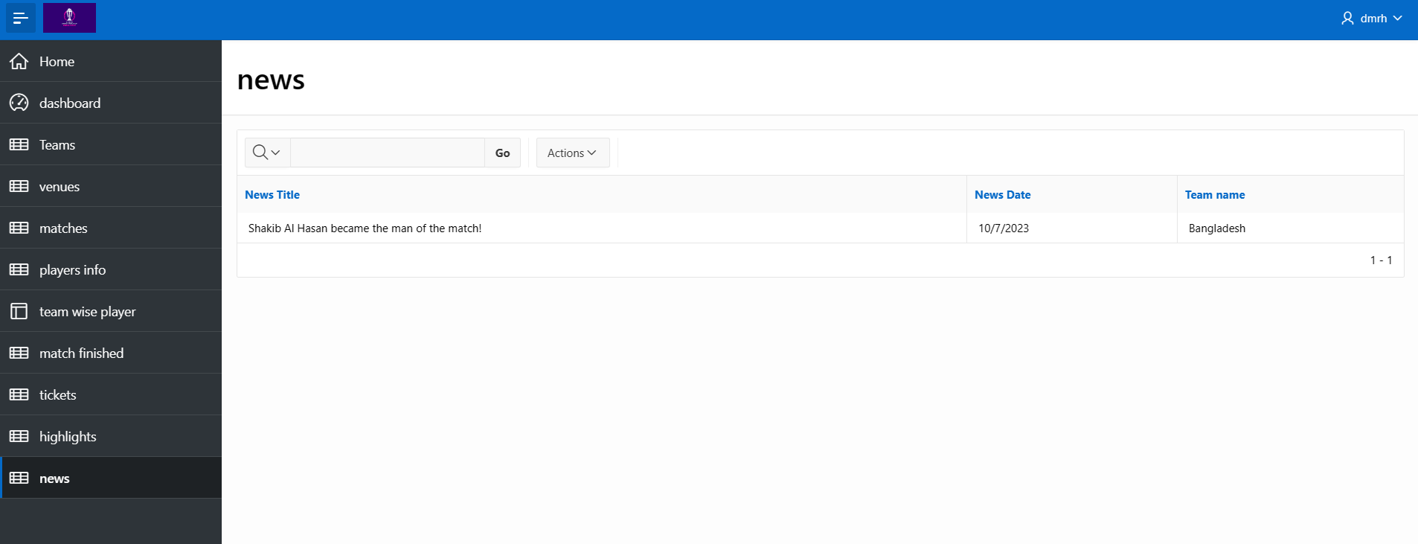
3.8 Report of news
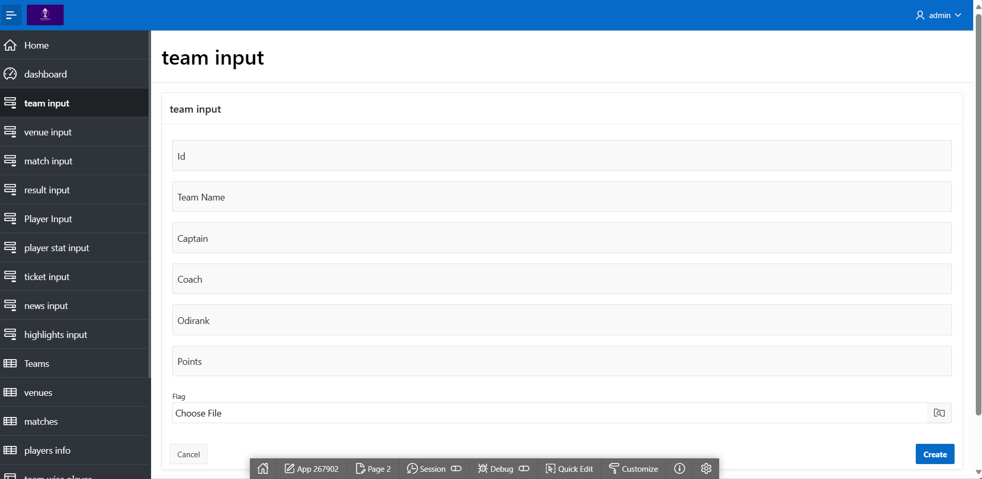
3.9 Form of team input

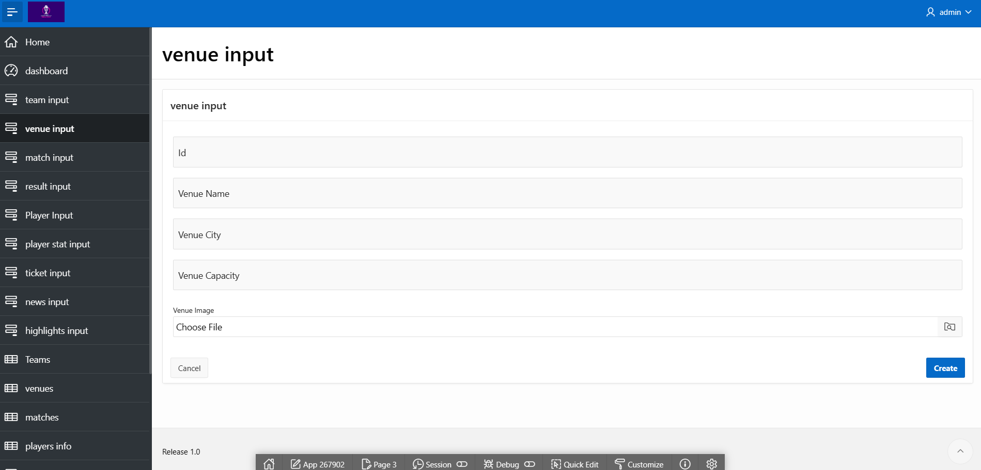
3.10 Form of venue input

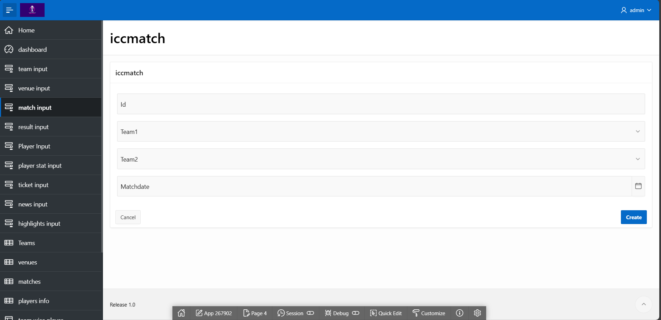
3.11 Form of iccmatch input

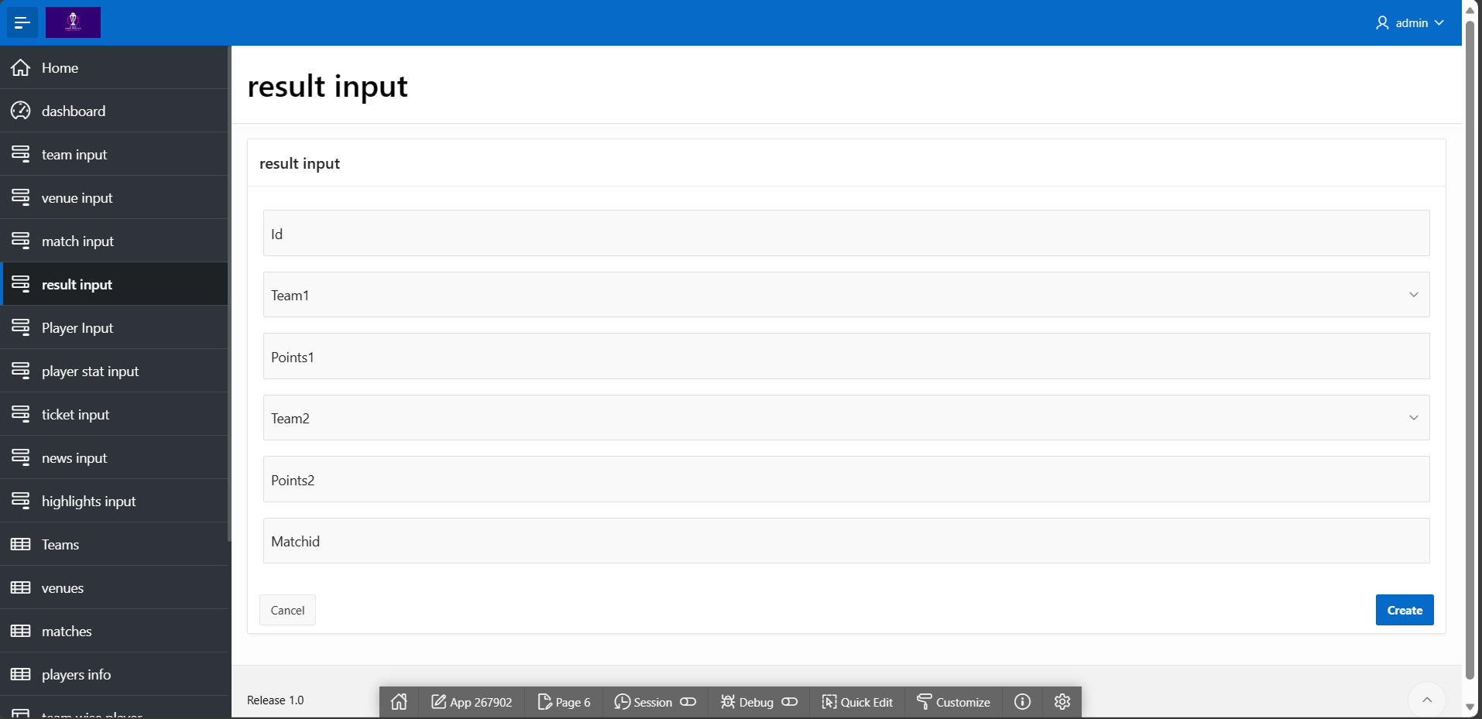
3.12 Form of result input

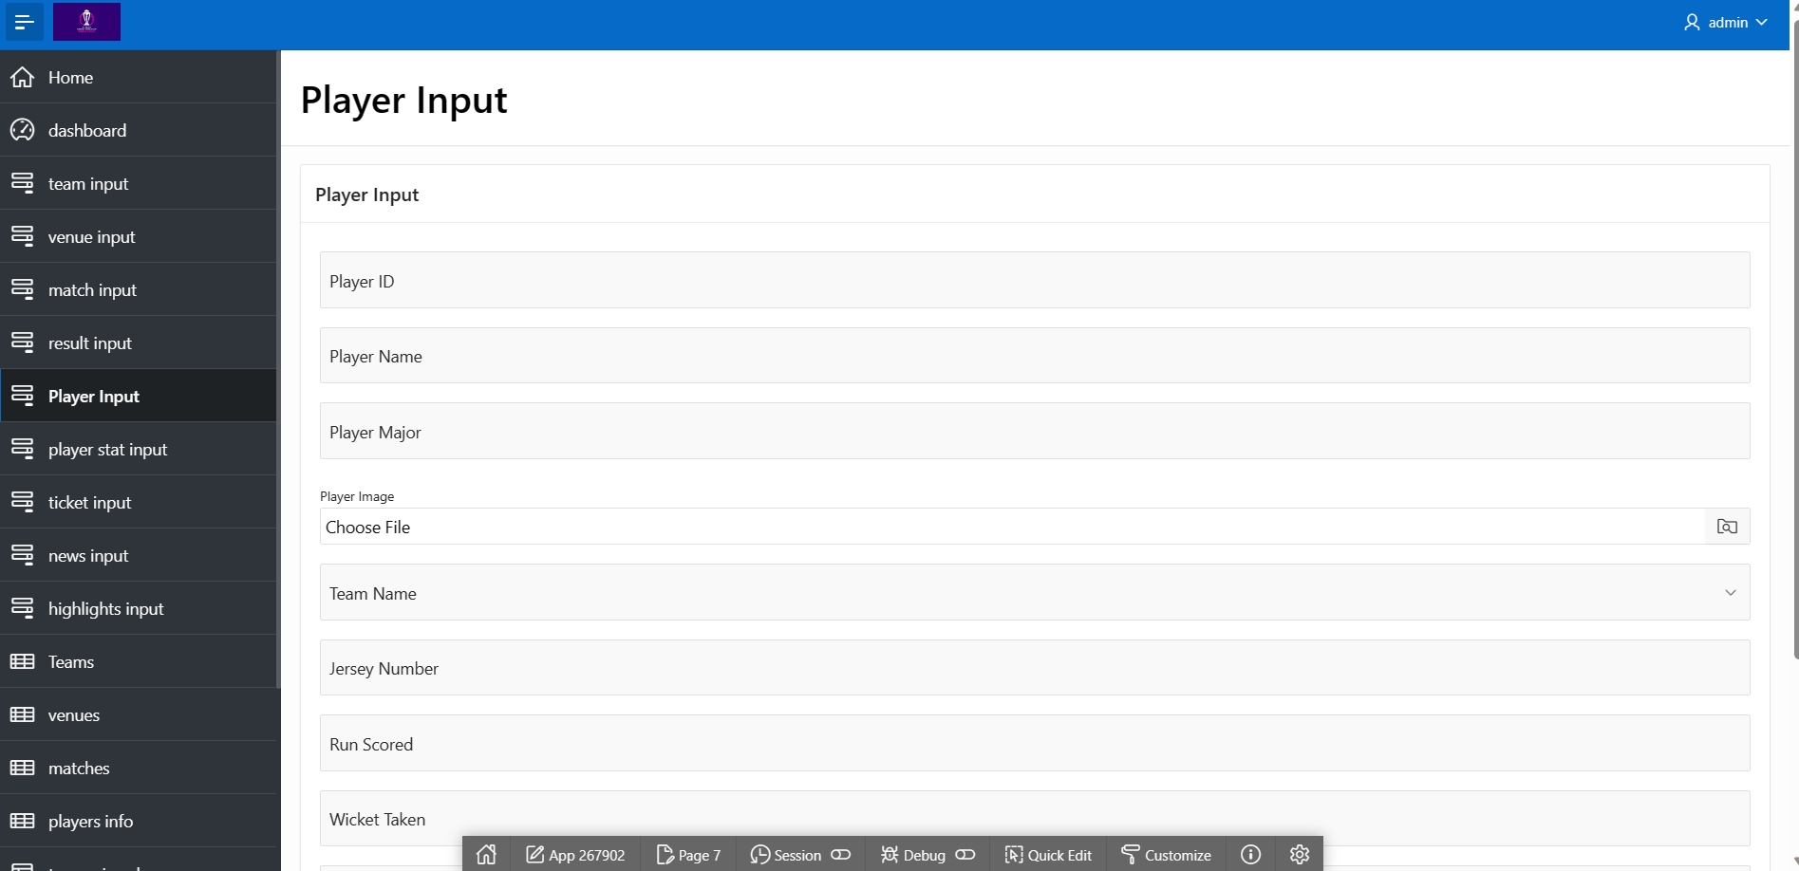
3.13 Form of player input

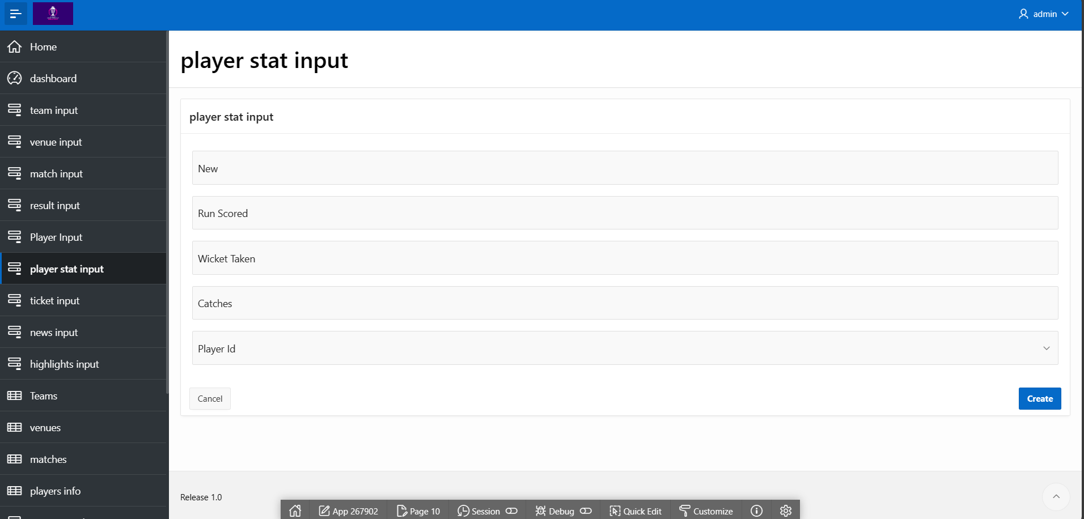
3.14 Form of player stat input

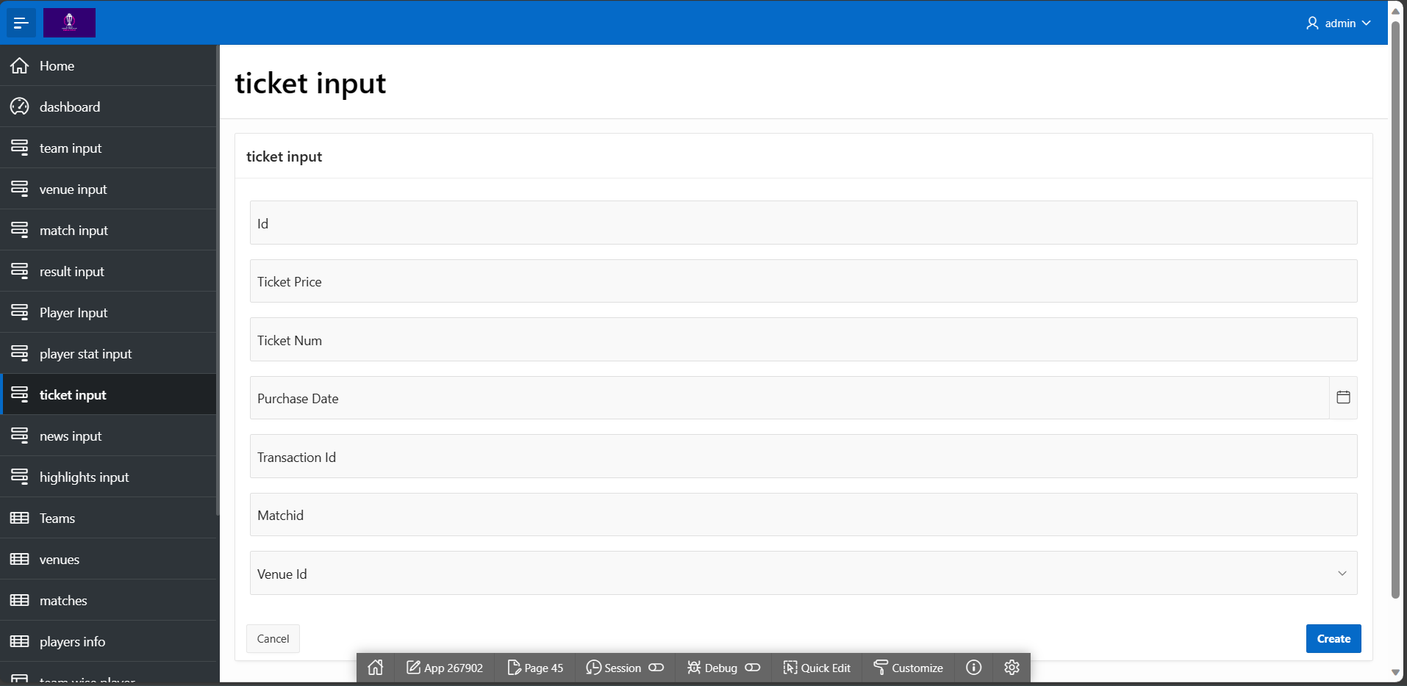
3.15 Form of ticket input

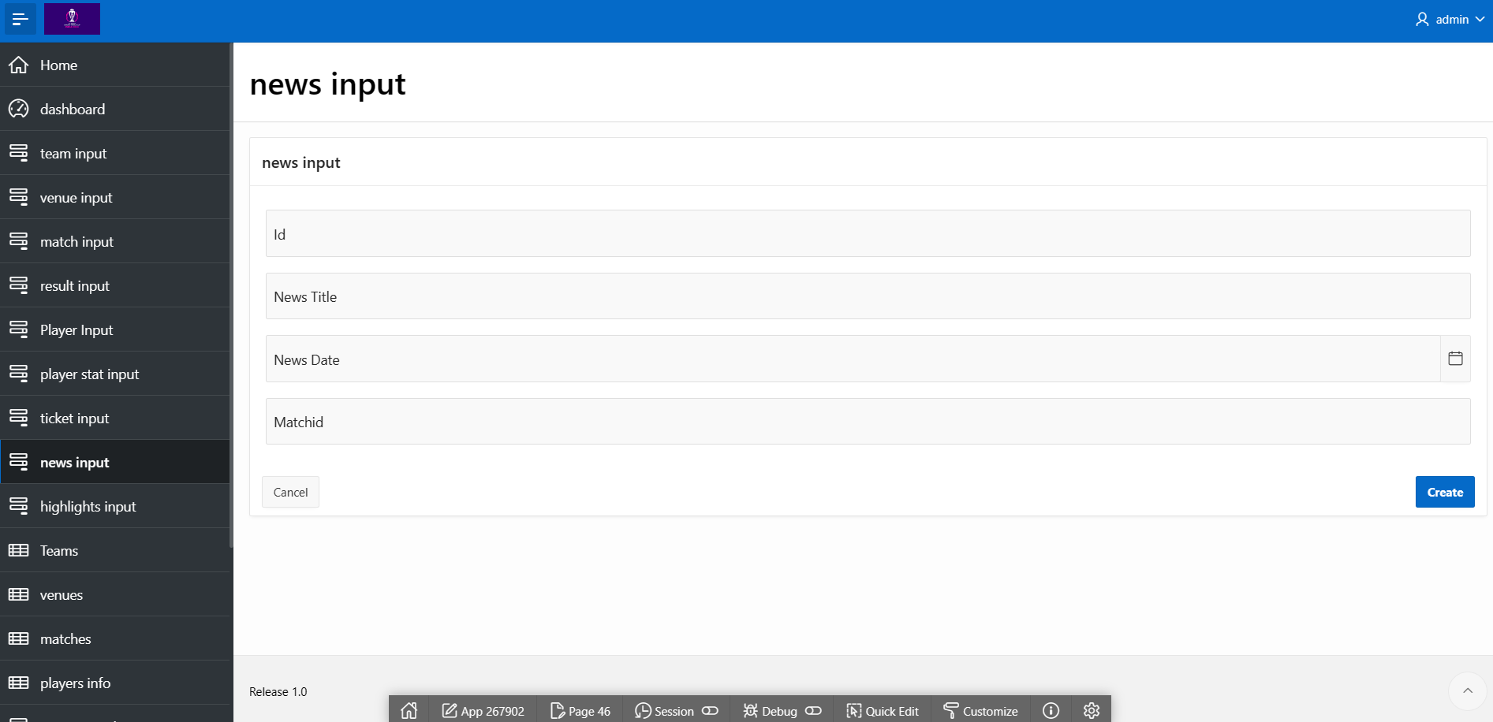
3.16 Form of news input

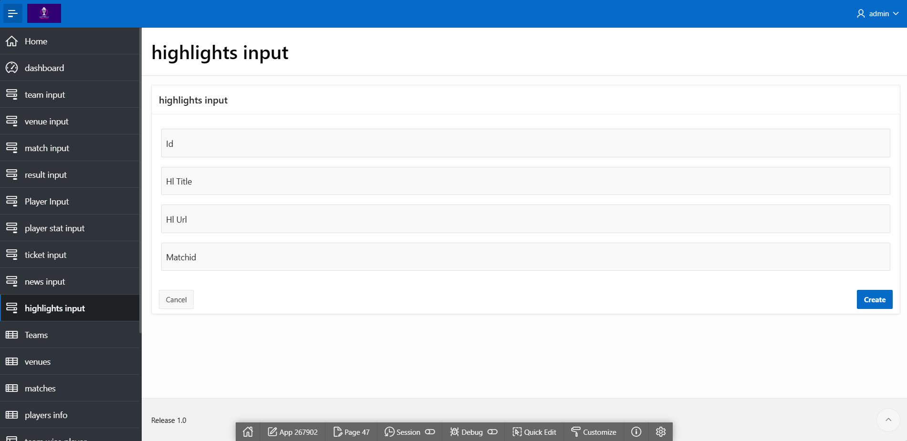
3.17 Form of highlights input

4. Master-Detail Form

Page Number and Name | Master Table (Parent) | Detail Table (Child)
35 - team wise player | Team | Player

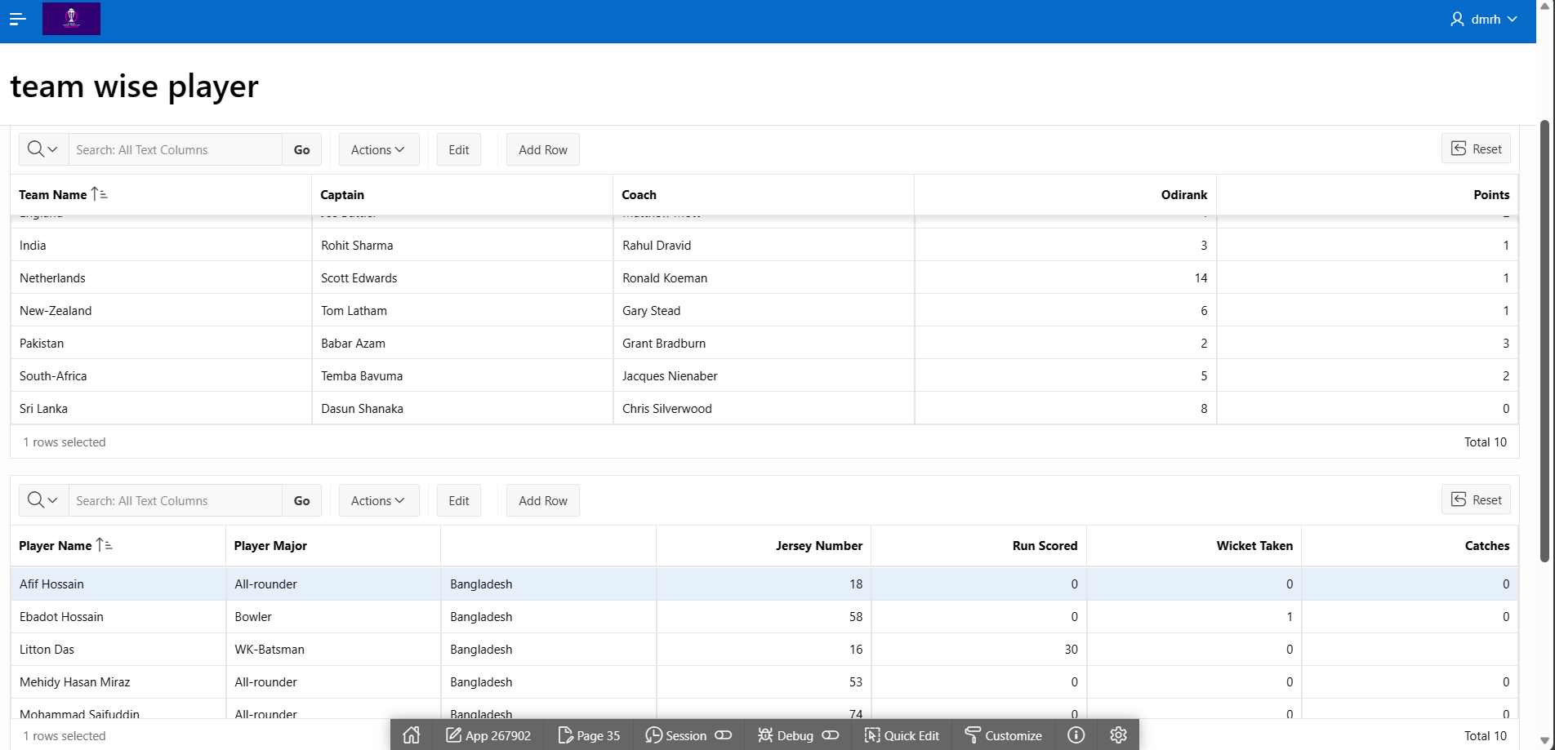
team-wise player Information

5. Reports based on Multi-Table and Aggregate Queries

Page Number and Name | Query Type | Report description
44 - dashboard | Multi-table/Aggregate | Team wise players

6. Parameterized Reports
Page Number and Name | Given Input | Report description
44 - dashboard | graph | Top 5 players by runs and wicket taken

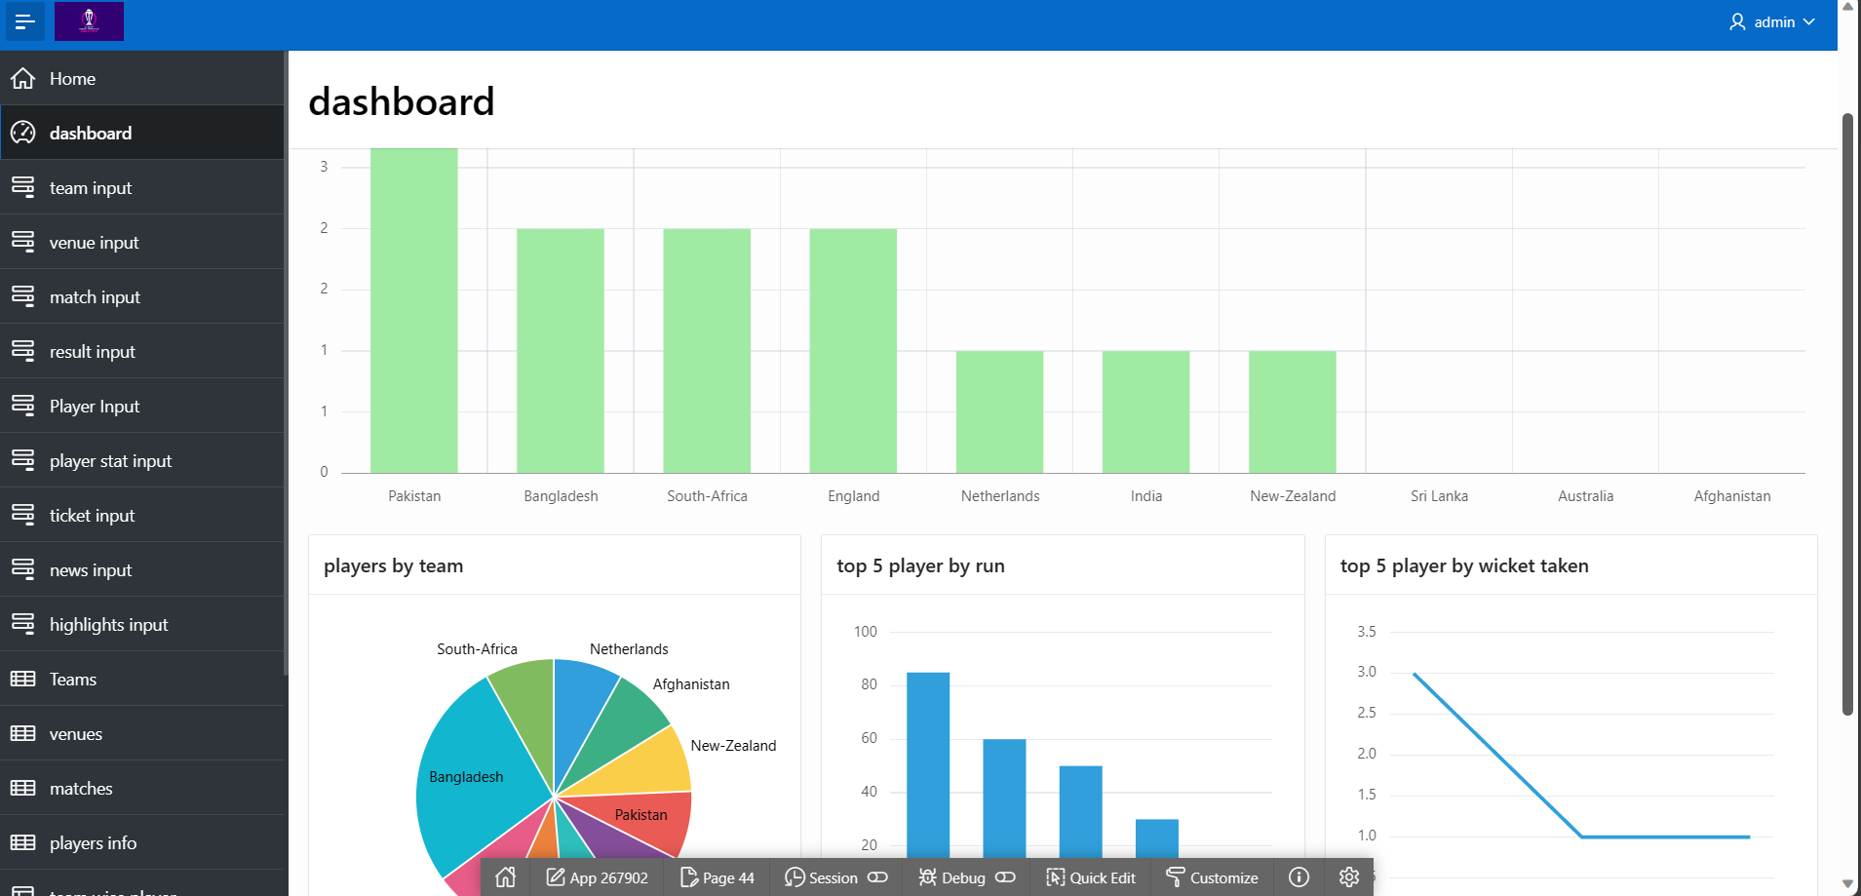

7. Charts and Other Pages

Page Number and Name | Chart description
57 - team wise player graph | Shows the players count by team

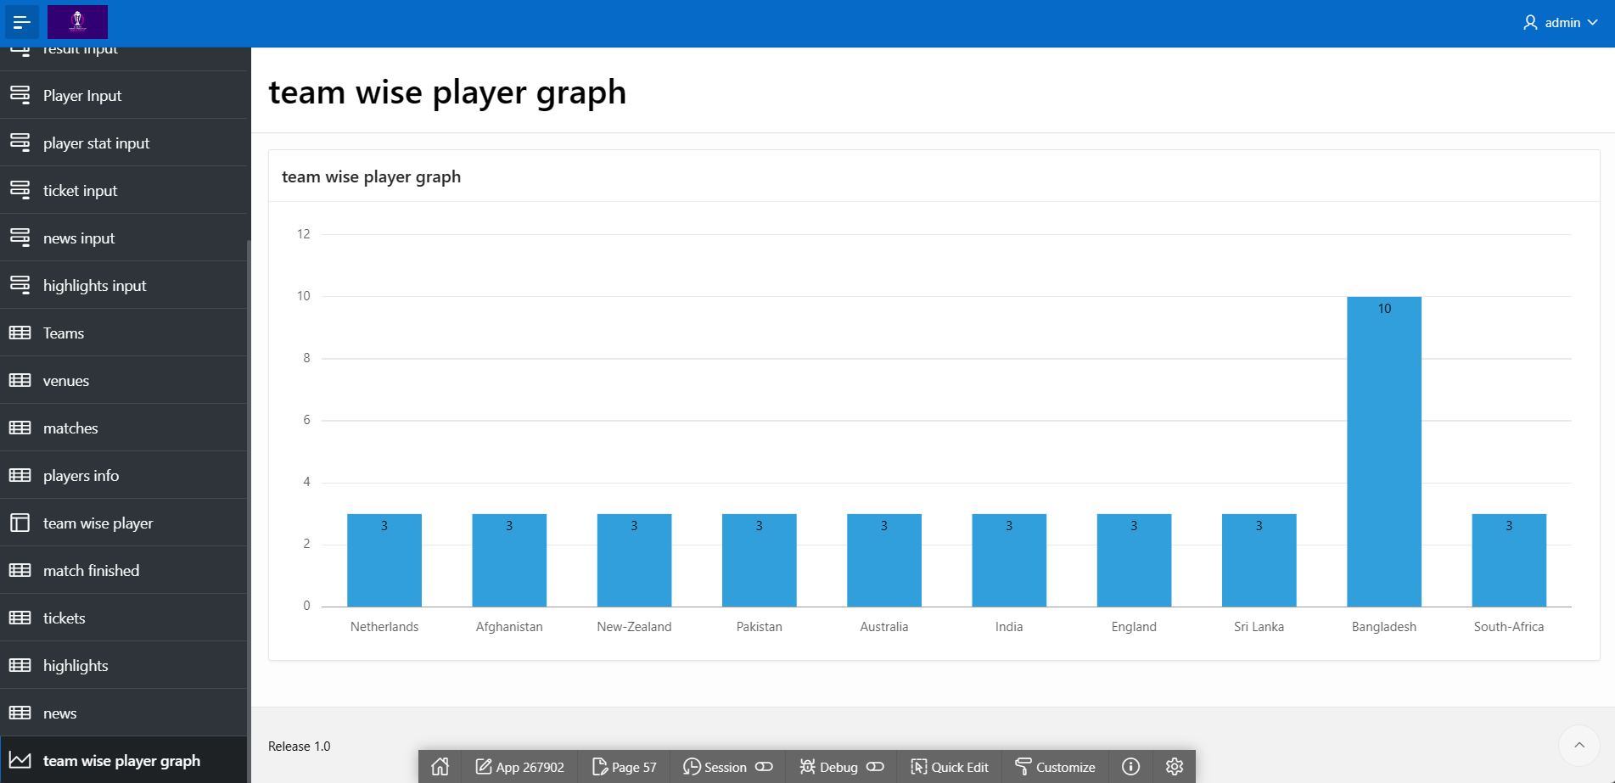
7.1 Chart of team wise player graph

8. Authorization and User Role Assignment

User Role Assignment

User name | Password | Role
DMRH | DMRH | Reader
ADMIN | ADMIN | Administrator
sagorahmedmunna@gmail.com | cse302project | Administrator

Page-wise Authorization Information

Page number and name | Authorization Level
2 - team input | Administrator
3 - venue input | Administrator
4 - match input | Administrator
6 - result input | Administrator
7 - player input | Administrator
8 - player stat input | Administrator
38 - Registration | Administrator
45 - ticket input | Administrator
46 - news input | Administrator
47 - highlights input | Administrator
11 - Teams | Reader
13 - venues | Reader
16 - matches | Reader
41 - match finished | Reader
22 - players info | Reader
48 - tickets | Reader
52 - news | Reader
50 - highlights | Reader
44 - dashboard | Reader
57 - team wise player graph | Reader

9. Concluding Remarks

We have developed an application for the ICC Men’s Cricket World Cup on apex oracle. As we are beginners, it was kinda hard for the two of us to complete the whole process of building the app. We had to change our ER Model so many times throughout the process and it was kind of frustrating. Lastly we decided to go with the above design and execute the whole thing in the apex oracle. We have learned so many things like form making, report making, designing, creating master table, executing triggers, dashboard customization and many more. Moreover, it was a really overwhelming experience. Thank you for this opportunity.

